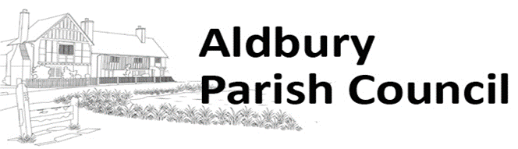

Dacorum’s Local Plan – Emerging /Strategy for Growth
Submission by Aldbury Parish Council
Aldbury Parish Council believes that the proposed development in Tring is out of all proportion to the current size of the town. Assuming the ONS figure of 2.4 persons per household, 2731 new houses would increase the population by over 6,500. This would increase the size of the town by over 50 per cent. It is almost the same as giving ‘new town’ status to Tring, changing the town completely and rendering all its infrastructure totally inadequate.
Development of the land to the east of Tring between Station Road, Bulbourne Road and the Grand Union Canal would be particularly disastrous. As this Council stated in its 2017 submission, the effect of building housing along Station Road on this site will be to extend Tring Town geographically so that it absorbs the hamlet of Tring Station, the West Ward of Aldbury Parish. This would permanently remove the buffer zone between Tring Town and the Chilterns AONB. It would also impact adversely on visual aspects of the Chilterns AONB which covers part of the south side of Station Road opposite the site. The site also adjoins the Chilterns AONB to the east if it is developed as far as the Grand Union Canal. This green belt site provides a much needed buffer between Tring Town and the Chilterns AONB. The principles of the Green Belt are set out in the National Planning Policy Framework (NPPF) (Section 13 – paras 133 - 147). Green Belt exists to provide open space and to prevent urban sprawl. Urban sprawl is exactly what development of this land would create.
Although this housing would be closer to Tring Station than most of Tring, this station is already at full capacity. The trains are overcrowded and in normal times the station car park is full by 9 am. The road through the hamlet of Tring Station is narrow and crowded. New housing in Aylesbury Vale is already putting extra pressure on the station and this will only increase. Tring’s road links with other parts of the country are already inadequate. The A41 is heavily congested, particularly in the morning.
The Ashridge Estate, part of the Chilterns AONB and one of the National Trust’s largest woodland and downland properties, is already under severe pressure due to visitor numbers. Housing another 6,500 people on its doorstep would only contribute to its decline.
Aldbury Parish Council believes development of the land to the east of Tring, in particular, would be disastrous for the town of Tring, the Parish of Aldbury (which consists of Aldbury village and Tring Station) and the wider area. We believe these plans put a disproportional pressure on the town of Tring compared with other areas of Dacorum. We hope that these plans are the result of a now discredited algorithm forced on local councils by central government. We look forward to a complete rethink, leading to more measured plans which better meet the vision and objectives set out by Dacorum itself.
Aldbury Parish Council
January 2021

